HMS has Property Records they create in their NetSuite environment. They have a custom table created that is used to capture these Property Records.



The Property Record has a custom form that looks like this.

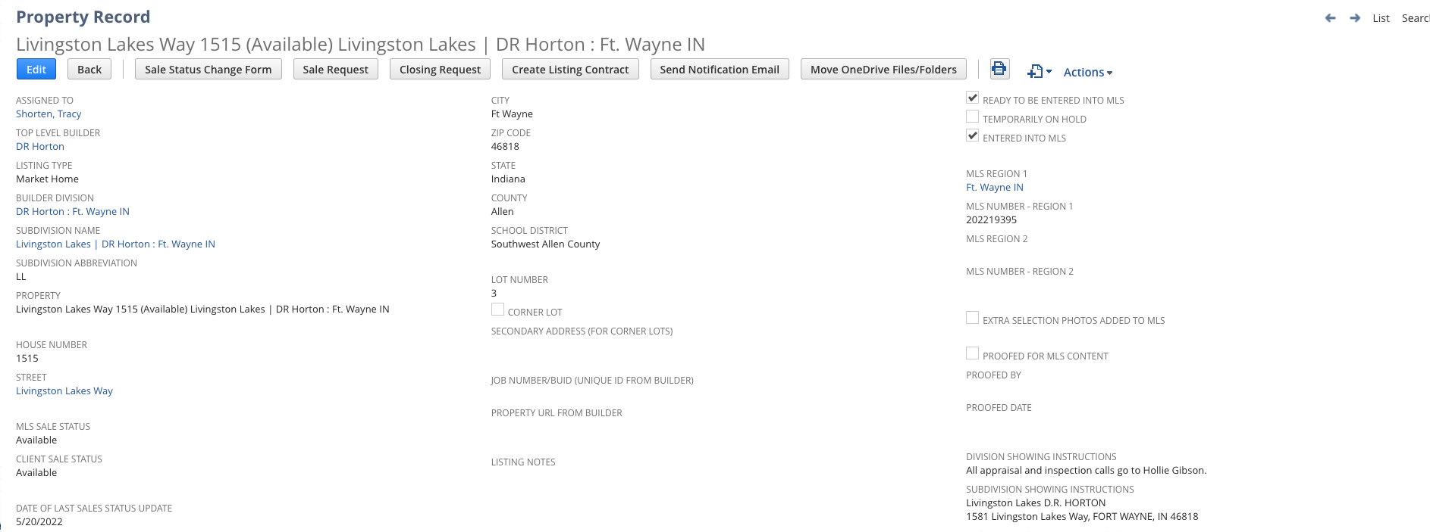

I believe the custom form used is this one

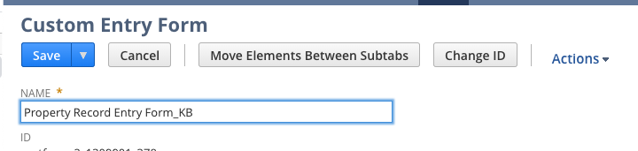

But in sandbox they do have this one marked as preferred on the custom record

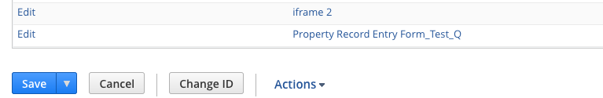

What they are looking for is to identify when certain fields are updated on this form and capture those in a custom table, much like we did for Delta Millworks for Customer Order Changes.

We need to create a custom table and similar scripting like we did for Delta Millworks to capture specific changes.

Custom Table: Please configure a custom record in NetSuite as follows

* Title Property Record Changes
* Fields
  + Property Name: This is titled as Property on the form, but is the ‘Name’ field as identified in the custom record. (free form text field)



* Date Changed: This would be the date the field value was changed. (date type field)
* Field Changed: This would be the field name that was changed. (free form text field)
* Old Value: This would be the previous value that was in the field. (free form text field)
* New Value: This would be the new value that is in the field. (free form text field)
* Changed By: This would be the username of who made the change. (free form text field)

The key fields we need to trigger on are as follows:

* Client Sales Status (see screenshot below): If this status update equals Pending or Closed, then log the information into the custom table. This is located on the Main section of the form.

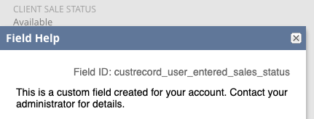

* Estimated Closing Date: If this field is updated at all, log a record in the custom table showing old value and new value. This is located under the Sales Details sub-tab of the Property form.

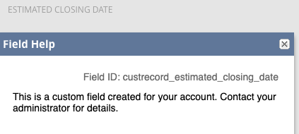

* When the Current Status of Construction field is updated, log a record in the custom table showing old value and new value. This field is located under the Listing Details sub-tab of the Property record.

ds

This is ideally a ‘real time’ update, so client or user event, but if we can’t do that it can be scheduled.

The updates to these fields can be manually done via the forms or (most likely) imported via API’s.

Again, this is really the same development we did for Delta Millworks, except it is being done on a different record type.

You can use this property record for testing in sandbox.

<https://1309901-sb1.app.netsuite.com/app/common/custom/custrecordentry.nl?rectype=18&id=43058&whence=>

Mike